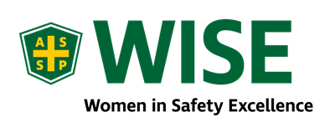
Training Opportunity: Fall Protection Competent Person

Louisville Chapter ASSP W.I.S.E. Members!

The Louisville Chapter has partnered with SafTtek to bring a Competent Person Fall Protection PDC designed specifically for female colleagues only. This one-time only course will be limited to the first 18 applicants and has been approved by ASSP for 3.2 CEU’s. To be eligible for the approved CEU’s the participant must attend each of the four 8-hour days on February 1, 8, 15, & 22. Each module will be taught through lecture and discussion, and will include printed material, discussion, and hands-on use and application, written testing and practical skills evaluation.
For registration and information regarding opportunity for scholarships for participants that are unable to obtain funding from employers, reply to president@louisville.assp.org with your name, Company and Title.
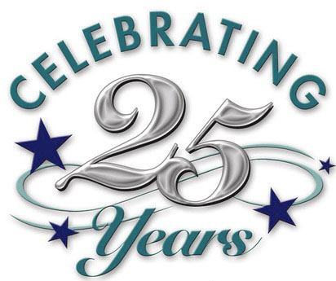
This Photo by Unknown Author is licensed under CC BY-ND
Congratulations!!!
Thank you for your membership!

The following members have completed 25 years of membership in ASSP:

- Gayla Anderson, September 1994
- William Wilkerson, January 1995
- Mark Bates, June 1995
- Gary Yurt, June 1995

Happy Holidays ASSP Luncheon
Please come mingle, eat and chat all things safety! For entry, please bring an unwrapped children's toy for Childrens' Hospital donation.
Date: Dec 20th from 11:30 am - 1:00 pm (Business Casual)
2713 Blankenbaker Rd, Louisville, Kentucky
This Photo by Unknown Author is licensed under CC BY-NC

Conference News

Bill Boehm, Chapter VP, attended this year’s Leadership Conference, October 10-12, at the Hyatt Regency O’Hare in Chicago, IL. This conference provided the following: developed leadership skills that are transferable to the workplace, shared best practices and met key ASSP leaders, and networked with other leaders in safety to find solutions to safety challenges. Boehm’s biggest takeaway was, “meeting new people that I will be working with virtually. It was worth my time and I would recommend this event for any ASSP member wanting to take on leadership opportunities.”

Meetings Past

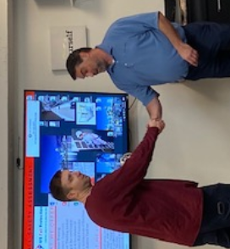
Fall Protection: Bryan Kline is the Mid-West Territory Sales and Marketing Manager for US Fall Protection. Bryan works with EHS, Facilities, and Maintenance personnel across a wide variety of industrial, manufacturing, and educational complexes, providing turnkey, design through installation, solutions to fall protection hazards according to current OSHA and ANSI standards for walking working surfaces. He spent over 25 years working in the building materials and construction industry, working closely with building contractors, in both the new and renovation, multi-family construction business.

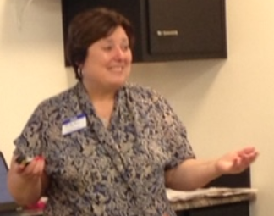
Proper PPE Fit – Women Emphasis: Ruby Ann Stevenson has worked in various industries including food and manufacturing. For the last 27 years, her career has been with ORR Safety Corporation where she is currently a Corporate Accounts Manager. She has assisted national accounts who needed to update PPE programs to be more inclusive and provide proper protection for all workers. She is a graduate of the University of Kentucky, B.A. Communications and Sullivan University, MBA.

